Name: Nitesh_Kumar (25K-0631)
Task-03
Question-01:

Yes, A friend function can be used to overload an operator like +=, even though it modifies the invoking object.
A friend function is not a member of the class, so it does not have access to the this pointer. Therefore, the left-hand operand must be passed explicitly as a reference parameter so that it can be modified.
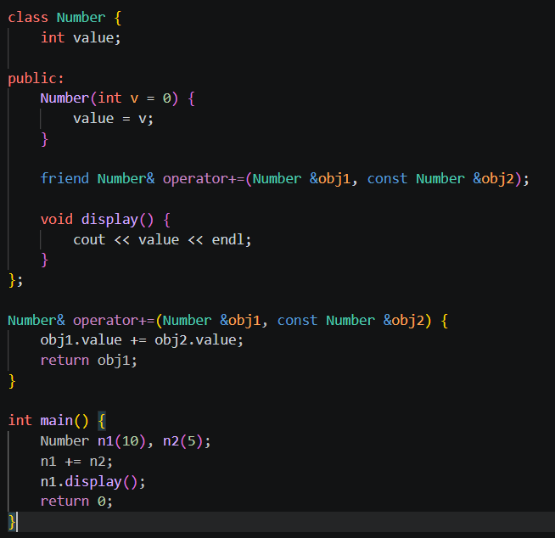
In this code, obj1 represents the left-hand object and is passed by reference so its value can be modified. The function returns a reference to allow chaining of operations.

Question-02
Yes, a friend function can be used to overload an operator when one of the operands is a primitive data type (such as int).
Friend functions are especially useful in this case because member functions cannot handle situations where the left-hand operand is a primitive type. A friend function allows both operands to be passed as parameters.
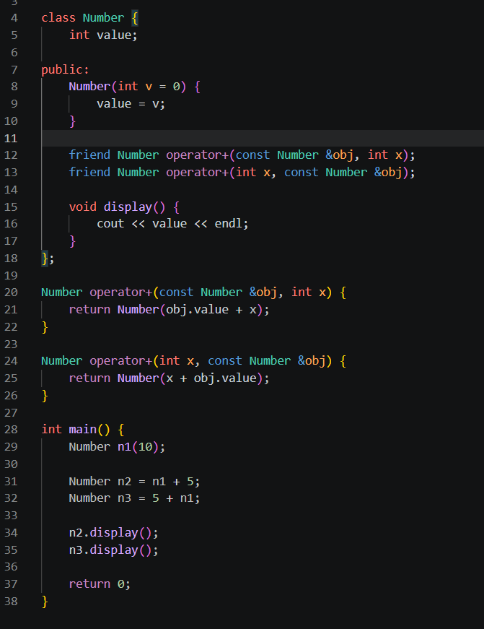
The friend function allows access to private data of the class. Both operands are passed as parameters, so it works even if one operand is a primitive type.
Member functions cannot overload operators when the left operand is a primitive type.Friend functions must be used in such cases to provide flexibility.

Question-3:
A friend function can access private and protected members of a class, but:
- It needs an object to access non-static members
- It can access members without an object only if they are static.
- It cannot access non-static members directly without an object.
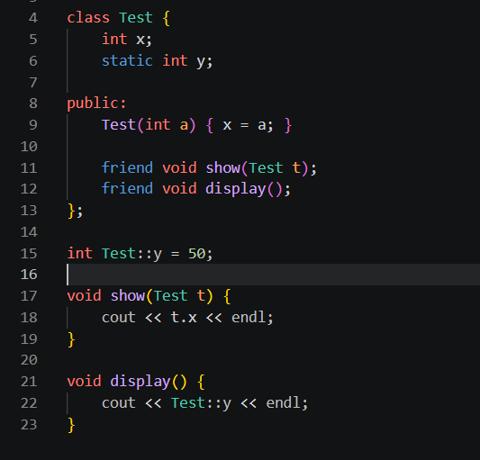

A friend function usually needs an object, except when accessing static members.

